**Roles**

**Scrum Team –** (*Is nothing but Test Team*)

* Team is cross-functional and consists of 5-9 people.
  + *Cross-functional => everyone should know all the functions of a product- (There is no dependency).*
* There are no set project roles within the team
  + *There is no differentiation role wise within the team. Everyone should play all the roles like Requirement Analysis, Test Case Design, Deployment, Test Execution, Automation Scripting, Defect logging.*
* Team defines tasks and assignments.
  + *Individual ownership.*
* Team is self-organizing and self-managing
  + *Priority wise working it depends upon functionality.*
  + *If they are facing any issue which affects deliverables that they should take responsibility and overcome it.*
* Maintains the Sprint Backlog
  + *Decides which are the stories has to be added or removed from the product backlog to the current sprint.*
* Conducts the Sprint Review
  + C*ertified the Sprint and releases to client.*
  + *During this meeting, the Scrum team shows what they accomplished during the sprint.*

**Product Owner (PO)**

* Accountable for product success
  + *Owner for the product.*
* Defines all product features
  + *Complete requirement*
* Responsible for prioritizing product features
  + *Priority the Stories.*
* Maintains the Product Backlog
  + *Stock the requirement.*
* Insures team working on highest valued features
  + *Ensures that the Scrum team completely focusing on high priority stories.*

**Scrum Master (SM**)**)**

* Holds daily 15 minute team meeting (Daily Scrum)
* Removes obstacles
  + *If my team facing any issues which affects the team deliverables so that the scrum master will try to resolve it for smooth release.*
* Shields the team from external interference
  + *Without my knowledge they should not work on any tasks.*
* Maintains the Sprint Burndown Chart
  + *It is a graphic representation that shows the rate at which work is completed and how much work remains.*

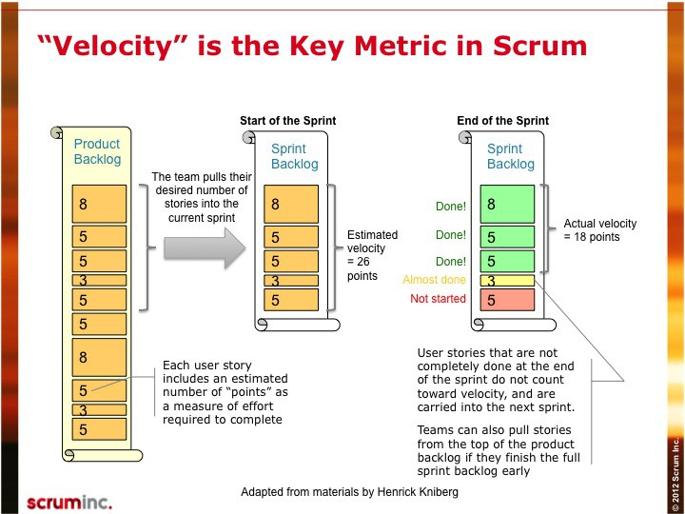

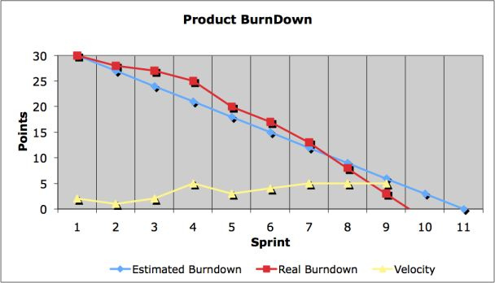

* Conducts Sprint Retrospective at the end of a Sprint
  + *It is a meeting facilitated by the Scrum Master at which the team discusses the just-concluded sprint and determines what could be change that might make the next sprint more productive.*
  + *It often also helps management to get feedback from the team about the work and progress of project.*
* Is a facilitator not a manager
  + *facilitator is to make a group's decision-making process easy, efficient, and effective.*

**Scrum Framework**

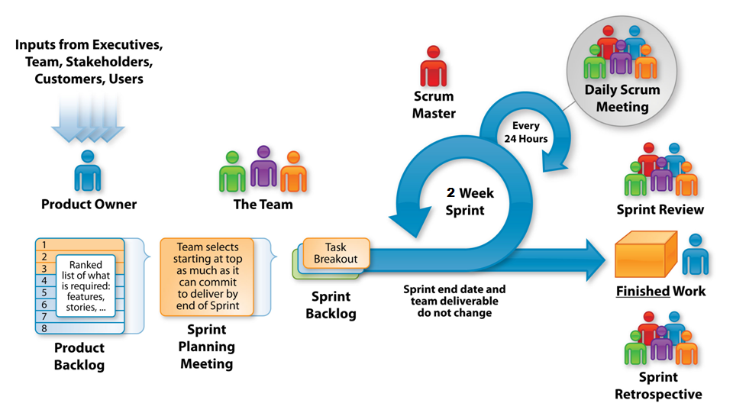The scrum framework contains the following processes.

|  |
| --- |
|  |

**Tools**

**Task Board**

* White Board containing teams Sprint goals, backlog items, tasks, tasks in progress, “DONE” items and the daily Sprint
  + *Sticky notes or index cards, one for each task the team is working on, are placed in the columns reflecting the current status of the tasks.*
* Burndown chart.
  + *A burn down chart is a graphical representation of work left to do versus time.*
  + *The outstanding work (or backlog) is often on the vertical axis, with time along the horizontal.*
  + *That is, it is a run chart of outstanding work.*
  + *It is useful for predicting when all of the work will be completed.*
* Scrum meeting best held around task board
  + daily scrum meeting*is held in the morning, as it helps set the context for the coming day's work.*
* Visible to everyone
  + Every one should know what is in progress and what has been completed.

**Artifacts**

**Product Backlog - (PB)**

* List of all desired product features
* List can contain bugs, and non-functional items
* Product Owner responsible for prioritizing
* Items can be added by anyone at anytime
* Each item should have a business value assigned
* Maintained by the Product Owner

**Sprint Backlog – (SB)**

* To-do list (also known as Backlog item) for the Sprint
  + stories
* Created by the Scrum Team
* Product Owner has defined as highest priority

**Burndown Chart – (BC**)

* Chart showing how much work remaining in a Sprint
* Calculated in hours remaining
* Maintained by the Scrum Master daily

**Release Backlog – (RB)**

* Same as the Product Backlog. May involve one or more sprints dependent on determined Release date

“DONE”= Potentially Shippable!

**FAQ**

* Who decides when a Release happens?
  + At the end of any given Sprint the PO can initiate a Release.
* Who is responsible for managing the teams?
  + The teams are responsible for managing themselves.
* What is the length of a task?
  + Tasks should take no longer than 16 hours. If longer then the task should be broken down further.
* Who manages obstacles?
  + Primary responsibility is on the Scrum Master. However, teams must learn to resolve their own issues. If not able then escalated to SM.
* What are two of the biggest challenges in Scrum?
  + Teams not self-managing, Scrum Master managing not leading.

**Meetings**

**Sprint Planning – Day 1 / First Half**

* Product backlog prepared prior to meeting
* First half – Team selects items committing to complete
* Additional discussion of PB occurs during actual Sprint

**Sprint Planning – Day 1 / Second Half**

* Occurs after first half done – PO available for questions
* Team solely responsible for deciding how to build
* Tasks created / assigned – Sprint Backlog produced

**Daily Scrum**

* Held every day during a Sprint
* Lasts 15 minutes
* Team members report to each other not Scrum Master
* Asks 3 questions during meeting
* “What have you done since last daily scrum?”
* “What will you do before the next daily scrum?”
* “What obstacles are impeding your work?”
* Opportunity for team members to synchronize their work

**Sprint Review**

* Team presents “done” code to PO and stakeholders
* Functionality not “done” is not shown
* Feedback generated - PB maybe reprioritized
* Scrum Master sets next Sprint Review

**Sprint Retrospective**

* Attendees – SM and Team. PO is optional
* Questions – What went well and what can be improved?
* SM helps team in discovery – not provide answers

**Visibility + Flexibility = Scrum**

**Glossary of Terms**

* Time Box - A period of time to finish a task. The end date is set and can not be changed
* Chickens – People that are not committed to the project and are not accountable for deliverables
* Pigs – People who are accountable for the project’s success
* Single Wringable Neck – This is the Product Owner!

**SCRUM CHEAT SHEET**

**Estimating**

**User Stories**

* A very high level definition of what the customer wants the system to do.
* Each story is captured as a separate item on the Product Backlog
* User stories are NOT dependent on other stories
* Story Template:
* “As a <User> I want <function> So that <desired result>
* Story Example:
* As a user, I want to print a recipe so that I can cook it.

**Story Points**

* A simple way to initially estimate level of effort expected to develop
* Story points are a relative measure of feature difficulty
* Usually scored on a scale of 1-10. 1=very easy through 10=very difficult
* Example:
* “Send to a Friend” Story Points = 2
* “Shopping Cart” Story Points = 9

**Business Value**

* Each User Story in the Product Backlog should have a corresponding business value assigned.
* Typically assign (L,M,H) Low, Medium, High
* PO prioritizes Backlog items by highest value

**Estimate Team Capacity**

* Capacity = # Teammates (Productive Hrs x Sprint Days)
* Example – Team size is 4, Productive Hrs are 5, Sprint length is 30 days.
* Capacity = 4 (5 x30) = 600 hours
* NOTE: Account for vacation time during the Sprint!

**Velocity**

* The rate at which team converts items to “DONE” in a single Sprint – Usually calculated in Story Points.

**General Terms used in AGILE-Scrum**

1. Scrum Team
2. Product Owner (PO)
3. Scrum Master (SM)
4. Product Backlog (PB)
5. Sprint Backlog (SB)
6. Burndown Chart (BC)
7. Release Backlog (RB)
8. DONE
9. Sprint Planning
10. Daily Scrum
11. Sprint Review
12. Sprint Retrospective
13. SCRUM CHEAT SHEET
14. User Stories
15. Story Points
16. Business value
17. Capacity
18. Velocity
19. Scrum Meeting